Provisio Group 3 Screen Capture

|  |  |
| --- | --- |
| **Name** | **Github ID** |
| Kyle Gotzman | ghostman5658 |
| Chee Her | cheher21 |
| Avery Owen | ajowen30 |
| Jonathan Sudhop | jsudhop |

Contents

About Us Page 3

Locations Page 4

Register Page 5

New User Register 5

New User Created 6

Login Page 7

Enter User Email and Password 7

Login Successful 8

Reservation Page 9

Not Logged In 9

Reservation Default View 9

Reservation Options Selected 10

Reservation Summary 11

Confirmation 11

Reservation Look Up Page 12

Not Logged In 12

No Reservations Set 12

View Reservation Detail 13

Loyalty Points Page 14

Not Logged In 14

View Loyalty Points and Attractions 14

# Landing/Index Page

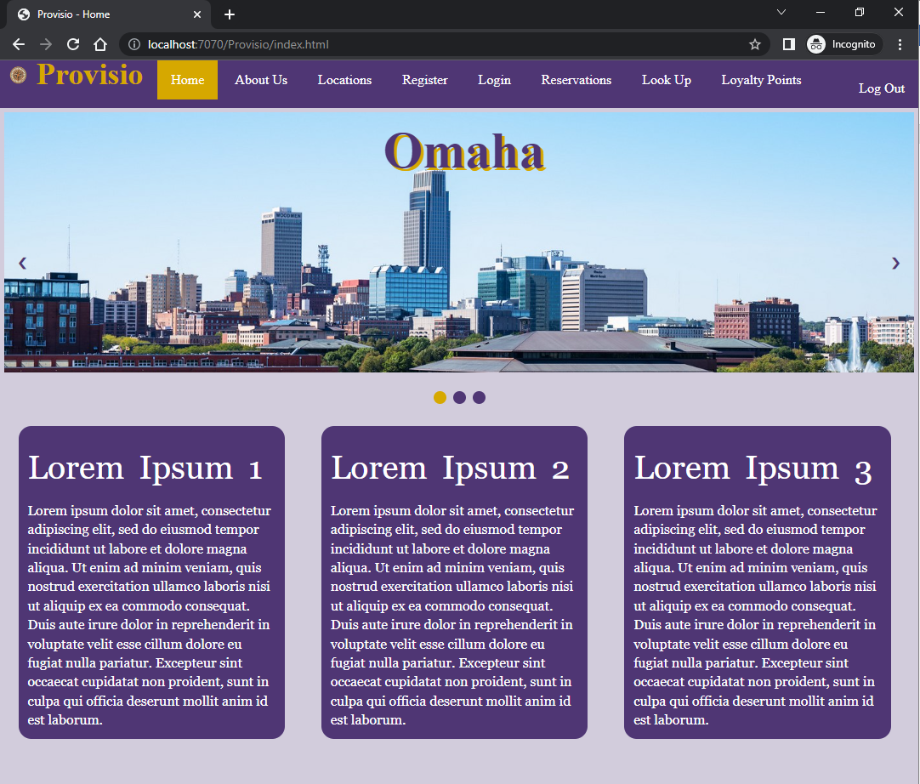

# About Us Page



# Locations Page

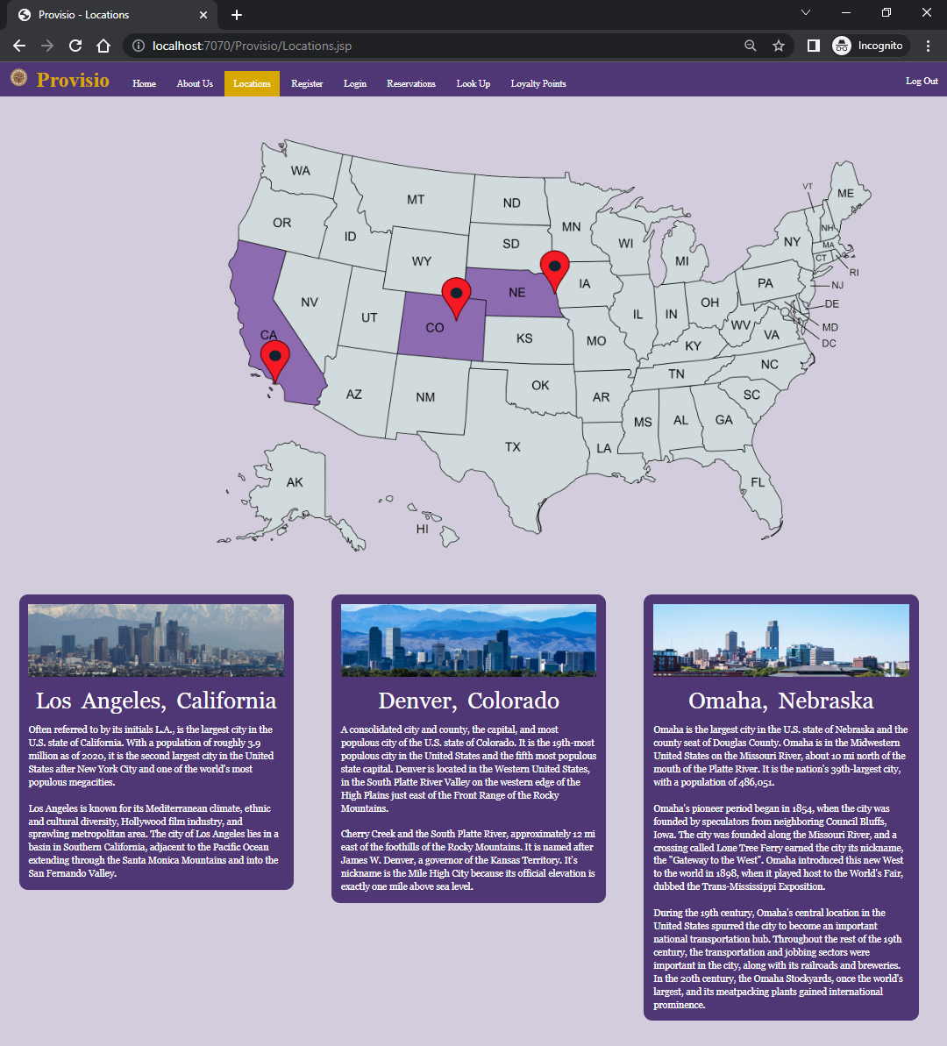

# Register Page

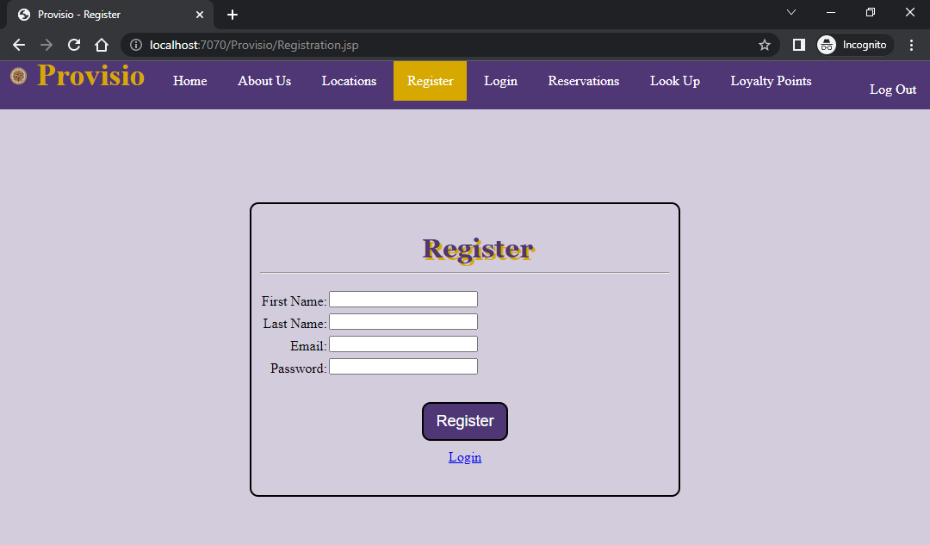

## New User Register

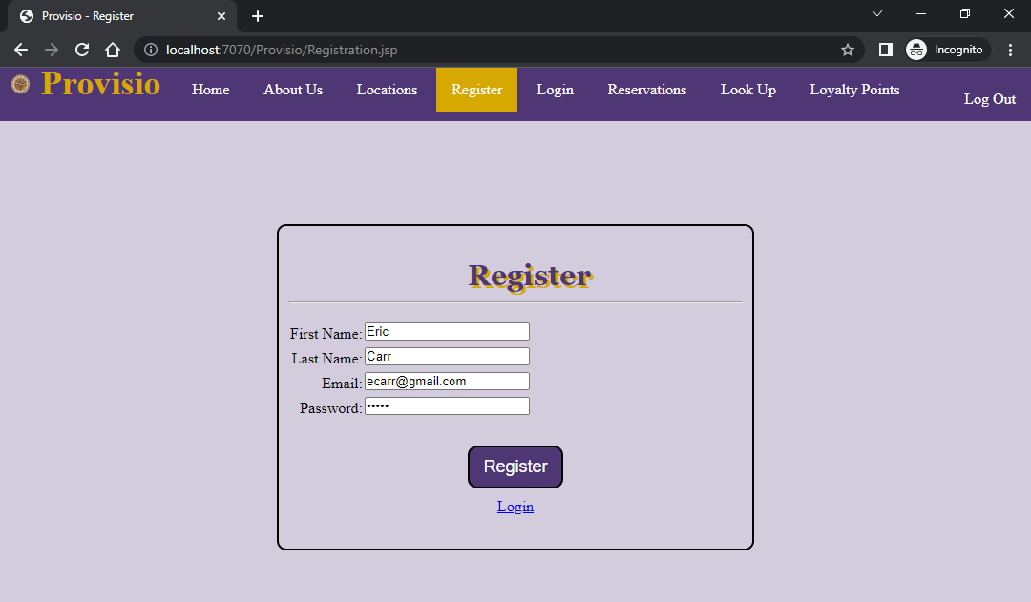

## New User Created

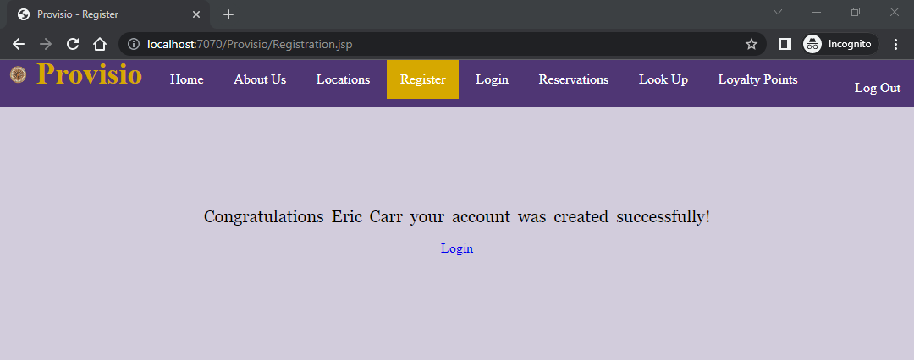

# Login Page

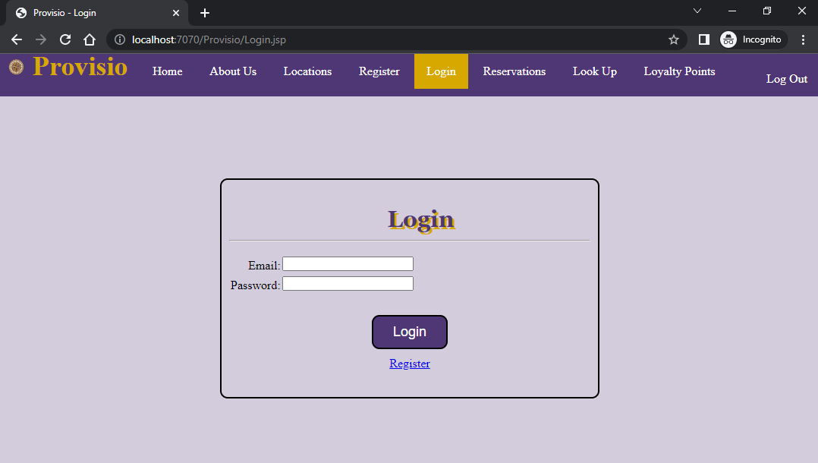

## Enter User Email and Password

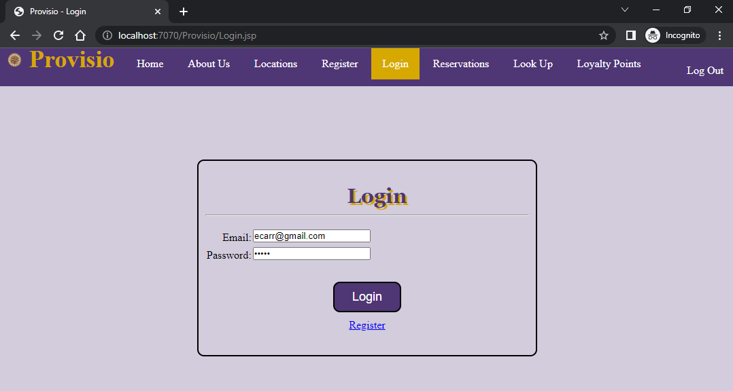

## Login Successful

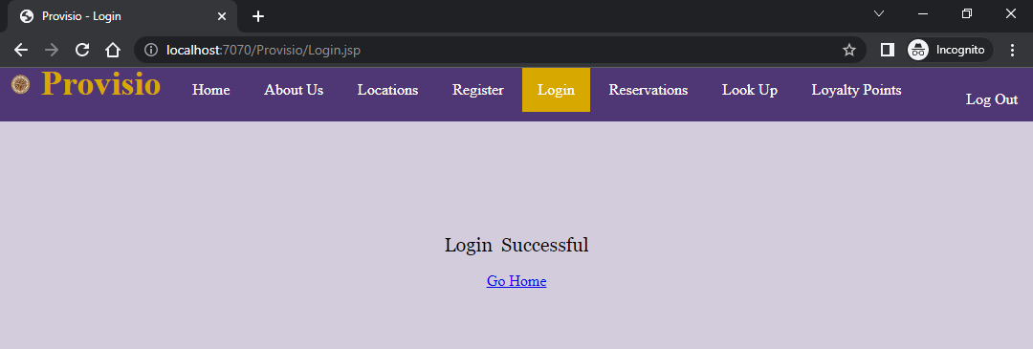

# Reservation Page

## Not Logged In

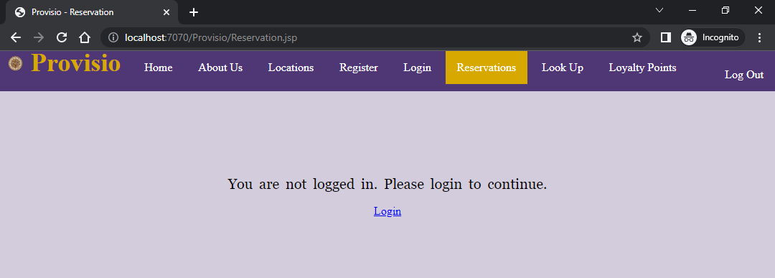

## Reservation Default View

No options selected

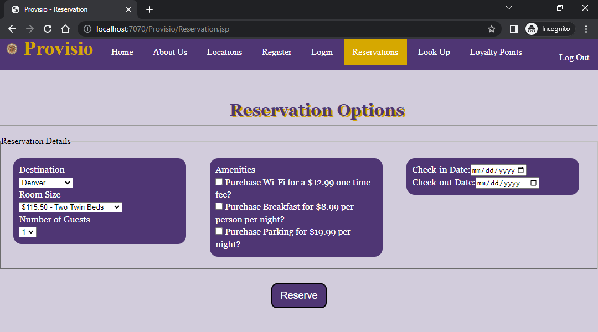

## Reservation Options Selected

Options selected

* Destination: Los Angeles
* Room Size: One Queen Bed
* Number of Guests: 2
* Amenities: Wifi & Breakfast
  + No Parking
* Check-in Date: 10/1/2022
* Check-out Date: 10/2/2022

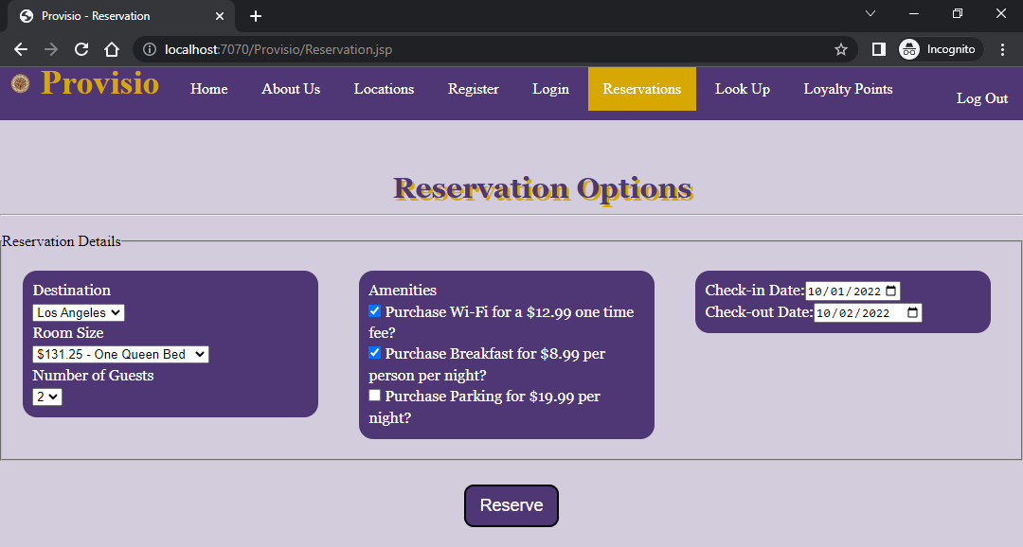

## Reservation Summary

Clicking the **Cancel** button will redirect user back to the **Reservation Page**

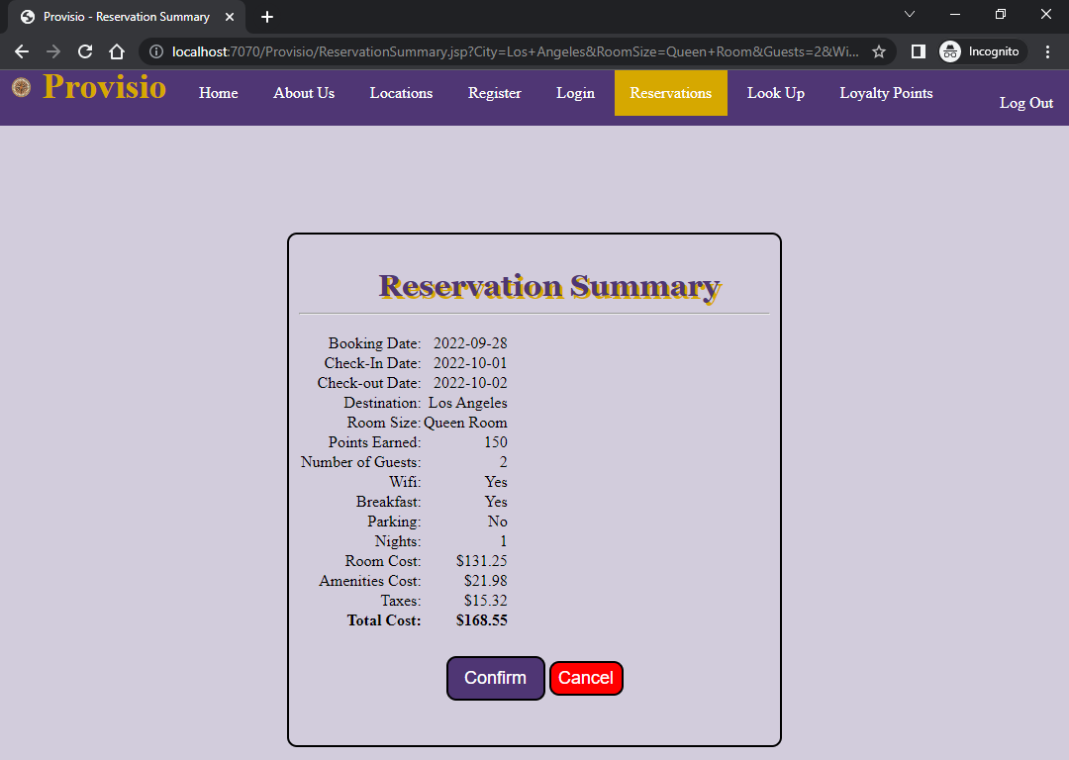

## Confirmation

Clicking on **Confirm** will book the user’s hotel selection

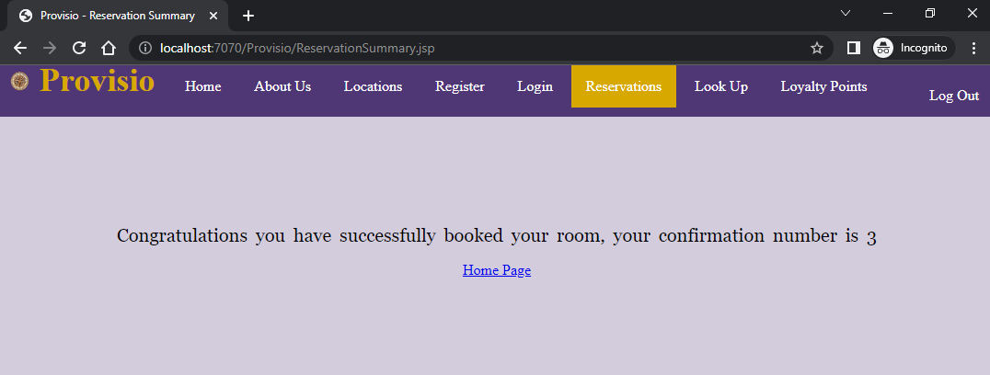

# Reservation Look Up Page

## Not Logged In

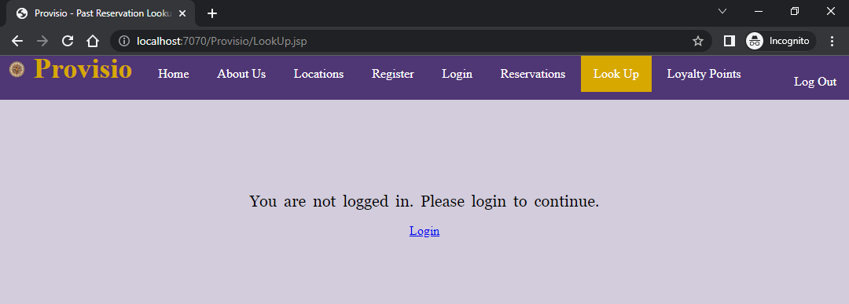

## No Reservations Set

User has not made any reservations

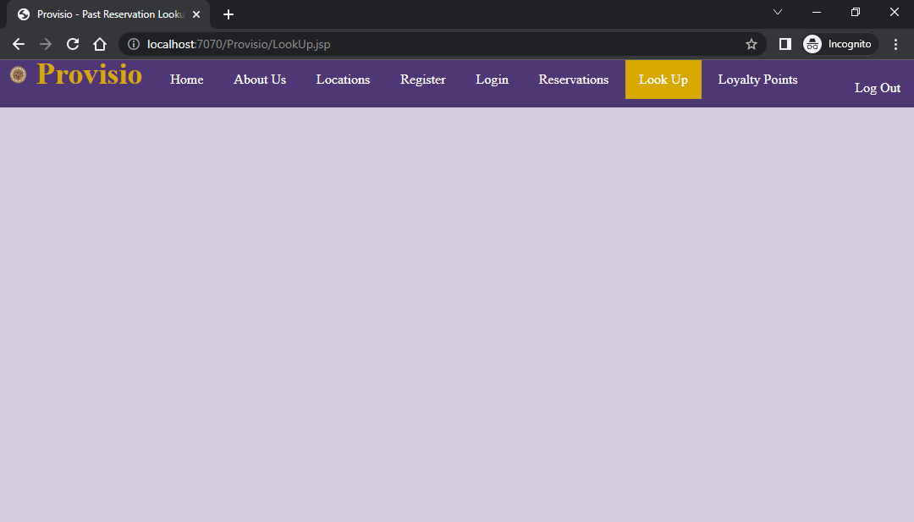

## View Reservation Detail

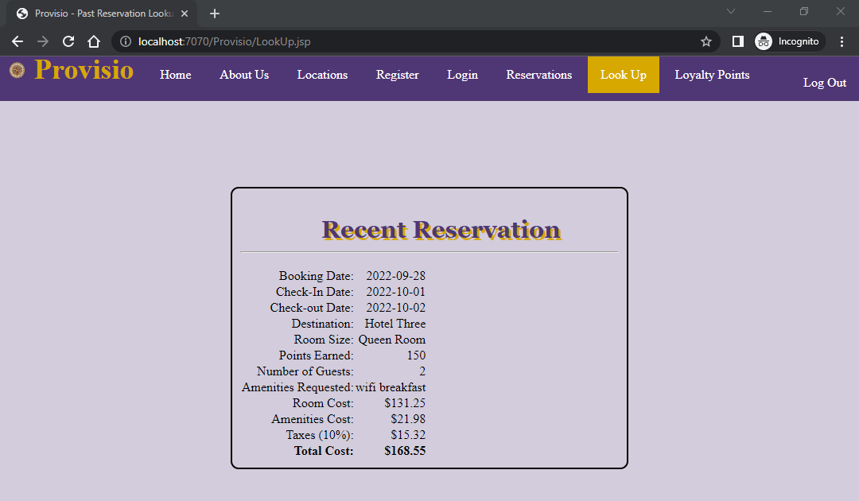

# Loyalty Points Page

## Not Logged In

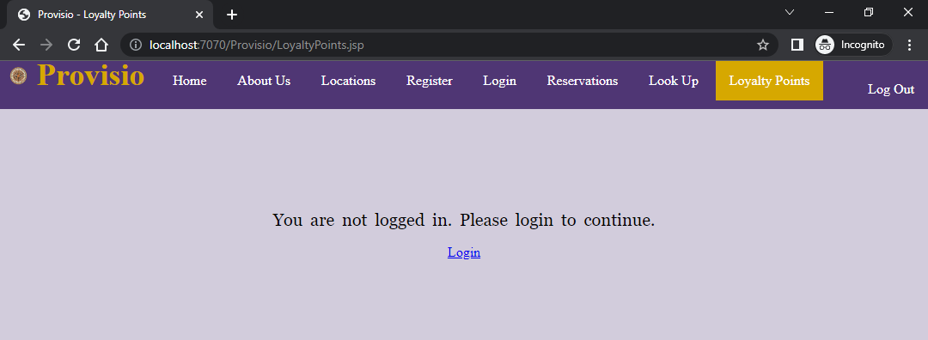

## View Loyalty Points and Attractions

Attractions are show according to user’s booking location. In this case, it is Los Angeles

